Assignment 3

OOP

Maxwell Maia

Student ID: 21236277

24/10/2022

Assignment Description

The point of this exercise is to practise inheritance.

Inheritance is used to avoid the repetition of attributes and methods.

Inheritance also allows polymorphism. Polymorphism is a property of an object that comes by an object being a one class of MANY classes that are inherited by a parent class. A reference variable of the parent or “super class” can store any of these objects.

Assignment description:

1. Make this inheritance tree.

2. Make custom toString() methods. This will print out information about the object.

3. Make custom equals(Object obj) methods. This will check whether two objects are the same or not by my own definition.

4. Make a move(int distance) method. For an Ostrich object the code should output “I am a bird but cannot fly” in the simplest way possible.

AnimalTest code

/\*\*

\* @author Maxwell Maia

\* Class used to test the program.

\*/

public class AnimalTest

{

public AnimalTest()

{

}

public static void main(String[] args)

{

//Create an object of the test class to run tests on.

AnimalTest test = new AnimalTest();

//Tests

test.testToString(); //test1: demonstrate toString functionality

test.testEquals(); //test2: demonstrate equals functionality

test.testMove(); //demonstrate move and sing methods wor

}

//test1

public void testToString()

{

System.out.println("=========Test 1=========");

System.out.println("Test toString in all classes.\n\n");

Animal[] animals = new Animal[4];

//This declares and allocates memory for an array of Animal references with 4 spaces

//Fill the Animals array with objects

animals[0] = new Canary("Bluey");

animals[1] = new Ostrich("Osty");

animals[2] = new Shark("Hark");

animals[3] = new Trout("Smekko");

//For each element in the animal array

// print out what is inside that element (toString)

for(Animal animal : animals)

{

System.out.println(animal); //call toString() the animal

}

}

//test2

public void testEquals()

{

System.out.println("\n\n\n=========Test 2=========");

System.out.println("Test the equals method in all classes.\n\n");

//CANARY

//Create an array for canaries

Canary[] canary = new Canary[3];

//Create some animals

canary[0] = new Canary("jOhn");

canary[1] = new Canary("jOhn");

canary[2] = new Canary("Rizz");

//.equals checking for Canary

// equal

System.out.println("Canary called " + canary[0].getName() +" vs " + canary[1].getName() + " are they equal? ");

System.out.println(canary[0].equals(canary[1]) ? "true" : "false");

// not equal

System.out.println("Canary called " + canary[0].getName() +" vs " + canary[2].getName() + " are they equal? ");

System.out.println(canary[0].equals(canary[2]) ? "true" : "false");

//Formatting

System.out.println("\n\n");

//OSTRICH

//Create an array for ostriches

Ostrich[] ostrich = new Ostrich[3];

//Create some animals

ostrich[0] = new Ostrich("Maxwell");

ostrich[1] = new Ostrich("Maxwell");

ostrich[2] = new Ostrich("Ganyu");

//.equals checking for Canary

// equal

System.out.println("Ostrich called " + ostrich[0].getName() +" vs " + ostrich[1].getName() + " are they equal? ");

System.out.println(ostrich[0].equals(ostrich[1]) ? "true" : "false");

// not equal

System.out.println("Ostrich called " + ostrich[0].getName() +" vs " + ostrich[2].getName() + " are they equal? ");

System.out.println(ostrich[0].equals(ostrich[2]) ? "true" : "false");

//Formatting

System.out.println("\n\n");

//SHARK

//Create an array for ostriches

Shark[] shark = new Shark[3];

//Create some animals

shark[0] = new Shark("Yanfei");

shark[1] = new Shark("Yanfei");

shark[2] = new Shark("BOBBLES");

//.equals checking for Canary

// equal

System.out.println("Shark called " + shark[0].getName() +" vs " + shark[1].getName() + " are they equal? ");

System.out.println(shark[0].equals(shark[1]) ? "true" : "false");

// not equal

System.out.println("Shark called " + shark[0].getName() +" vs " + shark[2].getName() + " are they equal? ");

System.out.println(shark[0].equals(shark[2]) ? "true" : "false");

//Formatting

System.out.println("\n\n");

//TROUT

//Create an array for ostriches

Trout[] trout = new Trout[3];

//Create some animals

trout[0] = new Trout("Ahri");

trout[1] = new Trout("Ahri");

trout[2] = new Trout("Redox");

//.equals checking for Canary

// equal

System.out.println("Trout called " + trout[0].getName() +" vs " + trout[1].getName() + " are they equal? ");

System.out.println(trout[0].equals(trout[1]) ? "true" : "false");

// not equal

System.out.println("Trout called " + trout[0].getName() +" vs " + trout[2].getName() + " are they equal? ");

System.out.println(trout[0].equals(trout[2]) ? "true" : "false");

//Formatting

System.out.println("\n\n");

//Are different object types equal

System.out.println("\nChecking that equals methods work for different types\n");

Animal[] animals = new Animal[4];

animals[0] = new Trout("Ahri");

animals[1] = new Shark("Yanfei");

animals[2] = new Canary("Rizz");

animals[3] = new Ostrich("Maxwell");

//.equals checking for different types

// equal

System.out.println("Trout called '" + animals[0].getName() +"' vs Trout called '" + animals[0].getName() + "' are they equal? ");

System.out.println(animals[0].equals(animals[0]) ? "true" : "false");

// not equal

System.out.println("Trout called '" + animals[0].getName() +"' vs Shark called '" + animals[1].getName() + "' are they equal? ");

System.out.println(animals[0].equals(animals[1]) ? "true" : "false");

// not equal

System.out.println("Ostrich called '" + animals[3].getName() +"' vs Trout called '" + animals[0].getName() + "' are they equal? ");

System.out.println(animals[3].equals(animals[0]) ? "true" : "false");

// not equal

System.out.println("Ostrich called '" + animals[3].getName() +"' vs Canary called '" + animals[2].getName() + "' are they equal? ");

System.out.println(animals[3].equals(animals[2]) ? "true" : "false");

}

public void testMove()

{

System.out.println("\n\n\n=========Test 3=========");

System.out.println("Test move() method in all classes.\n\n");

//Fill the Animals array with objects

Animal[] animals = new Animal[4];

animals[0] = new Canary("Bluey");

animals[1] = new Ostrich("Osty");

animals[2] = new Shark("Hark");

animals[3] = new Trout("Smekko");

//loop through animal array

for(Animal animal : animals)

{

animal.move(5); //test move() method

System.out.println(animal); //toString

}

}

}

AnimalTest test1 output

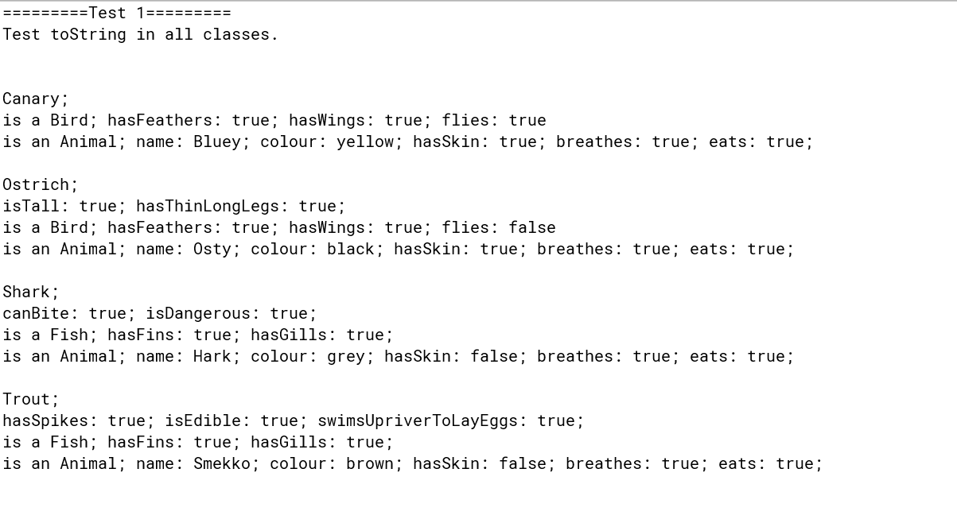

AnimalTest test2 output

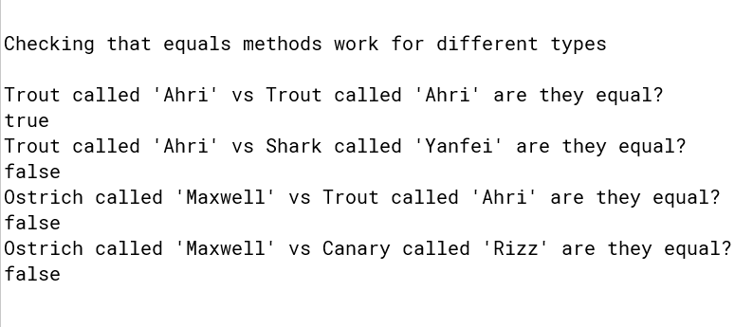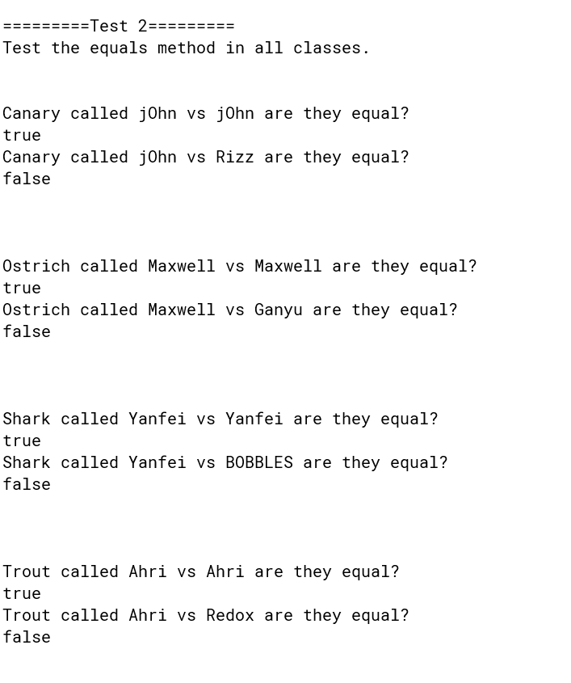

Canary code

public class Canary extends Bird

{

/\*\*

\* Constructor for objects of class Canary

\*/

public Canary(String name)

{

super(); // call the constructor of the superclass Bird

this.name = name; //overrides the name given in Animal

colour = "yellow"; // this overrides the value inherited from Bird

}

/\*\*

\* Sing method overrides the sing method

\* inherited from superclass Bird

\*/

@Override // good programming practice to use @Override to denote overridden methods

public void sing(){

System.out.println("tweet tweet tweet");

}

/\*\*

\* toString method returns a String representation of the bird

\* What superclass has Canary inherited this method from? java.lang.Object

\*/

@Override

public String toString()

{

String strng ="";

strng+= "Canary; ";

strng+= "\n";

// Include the fields and attributes inherited

//from Bird and Animal in the String representation

strng+= "is a Bird; ";

strng+= "hasFeathers: ";

strng+= hasFeathers;

strng+= "; ";

strng+= "hasWings: ";

strng+= hasWings;

strng+= "; ";

strng+= "flies: ";

strng+= flies;

strng+= "\n";

strng+= "is an Animal; ";

strng+= "name: ";

strng+= name;

strng+= "; ";

strng+= "colour: ";

strng+= colour;

strng+= "; ";

strng+= "hasSkin: ";

strng+= hasSkin;

strng+= "; ";

strng+= "breathes: ";

strng+= breathes;

strng+= "; ";

strng+= "eats: ";

strng+= eats;

strng+= "; ";

strng+= "\n";

return strng;

}

/\*\*

\* equals method defines how equality is defined between

\* the instances of the Canary class

\* param Object

\* return true or false depending on whether the input object is

\* equal to this Canary object

\*

\* Rules for equality

\* Same name, same colour

\*/

@Override

public boolean equals(Object obj){

//Make sure that the object reference isn't empty. (no object)

if(obj == null)

{

//no object (obj is null) was input to compare this object to

return false;

}

//Check that the object reference is the same class as this class

if(obj instanceof Canary)

{

//Upcast the object so that checks can be done below

Canary can = (Canary)obj;

//Check the rules for equality

if(this.name.equals(can.getName())

&& this.colour.equals(can.getColour()))

{

//the objects are equal

return true;

}

}

//the objects are not equal

return false;

}

}

Ostrich code

public class Ostrich extends Bird

{

boolean isTall;

boolean hasThinLongLegs;

/\*\*

\* Constructor for objects of class Ostrich

// \*/

public Ostrich(String name)

{

super();

this.name = name; //Overrides value set in Animal.

isTall = true;

hasThinLongLegs = true;

flies = false; //Override value set in Bird. he can't fly :(

}

/\*\*

\* toString method returns a String representation of the bird

\* What superclass has Ostrich inherited this method from? java.lang.Object

\*/

@Override

public String toString()

{

String strng = "";

strng+= "Ostrich; ";

strng+= "\n";

strng+= "isTall: ";

strng+= isTall;

strng+= "; ";

strng+= "hasThinLongLegs: ";

strng+= hasThinLongLegs;

strng+= "; ";

strng+= "\n";

strng+= "is a Bird; ";

strng+= "hasFeathers: ";

strng+= hasFeathers;

strng+= "; ";

strng+= "hasWings: ";

strng+= hasWings;

strng+= "; ";

strng+= "flies: ";

strng+= flies;

strng+= "\n";

strng+= "is an Animal; ";

strng+= "name: ";

strng+= name;

strng+= "; ";

strng+= "colour: ";

strng+= colour;

strng+= "; ";

strng+= "hasSkin: ";

strng+= hasSkin;

strng+= "; ";

strng+= "breathes: ";

strng+= breathes;

strng+= "; ";

strng+= "eats: ";

strng+= eats;

strng+= "; ";

strng+= "\n";

return strng;

}

/\*

\* Equals method for leaf class.

\* This method defines what makes Ostrich objects equal

\* Returns true if the objects are equal, else false.

\*

\* Rules for equality

\* Same name, same isTall, same hasThinLongLegs

\*/

@Override

public boolean equals(Object obj)

{

if(obj == null)

{

//no object input

return false;

}

if(obj instanceof Ostrich)

{

Ostrich ost = (Ostrich)obj;

if(this.name.equals(ost.getName())

&& this.isTall == ost.isTall()

&& this.hasThinLongLegs == ost.hasThinLongLegs())

{

//objects equal

return true;

}

}

//objects not equal

return false;

}

//Getter for isTall attribute

public boolean isTall()

{

return isTall;

}

//Getter for hasThinLongLegs attribute

public boolean hasThinLongLegs()

{

return hasThinLongLegs;

}

}

Fish code

public abstract class Fish extends Animal

{

boolean hasFins;

boolean hasGills;

/\*\*

\* Constructor for objects of class Fish

\*/

public Fish()

{

hasFins = true;

hasGills = true;

hasSkin = false; //Override value set in Animal. All subclasses inherit this value.

}

@Override

public void move(int distance)

{

System.out.printf("I swim %d metres \n", distance);

}

//Getter for hasFins attribute

public boolean hasFins()

{

return hasFins;

}

//Getter for hasGills attribute

public boolean hasGills()

{

return hasGills;

}

}

Shark code

public class Shark extends Fish

{

boolean canBite;

boolean isDangerous;

/\*\*

\* Constructor for objects of class Shark

\*/

public Shark(String name)

{

super();

this.name = name; //Overrides value set in Animal.

canBite = true;

isDangerous = true;

}

/\*\*

\* toString method returns a String representation of the fish

\* What superclass has Shark inherited this method from? java.lang.Object

\*/

@Override

public String toString()

{

String strng = "";

strng+= "Shark; ";

strng+= "\n";

strng+= "canBite: ";

strng+= canBite;

strng+= "; ";

strng+= "isDangerous: ";

strng+= isDangerous;

strng+= "; ";

strng+= "\n";

strng+= "is a Fish; ";

strng+= "hasFins: ";

strng+= hasFins;

strng+= "; ";

strng+= "hasGills: ";

strng+= hasGills;

strng+= "; ";

strng+= "\n";

strng+= "is an Animal; ";

strng+= "name: ";

strng+= name;

strng+= "; ";

strng+= "colour: ";

strng+= colour;

strng+= "; ";

strng+= "hasSkin: ";

strng+= hasSkin;

strng+= "; ";

strng+= "breathes: ";

strng+= breathes;

strng+= "; ";

strng+= "eats: ";

strng+= eats;

strng+= "; ";

strng+= "\n";

return strng;

}

/\*

\* Equals method for leaf class.

\* This method defines what makes Shark objects equal

\* Returns true if the objects are equal, else false.

\*

\* Rules for equality

\* Same name, same canBite, same isDangrous

\*/

@Override

public boolean equals(Object obj)

{

if(obj == null)

{

//no object input

return false;

}

if(obj instanceof Shark)

{

Shark shk = (Shark)obj;

if(this.name.equals(shk.getName())

&& this.canBite == shk.canBite()

&& this.isDangerous == shk.isDangerous())

{

//objects equal

return true;

}

}

//objects not equal

return false;

}

//Getter for canBite attribute

public boolean canBite()

{

return canBite;

}

//Getter for isDangerous attribute

public boolean isDangerous()

{

return isDangerous;

}

}

Trout code

public class Trout extends Fish

{

boolean hasSpikes;

boolean isEdible;

boolean swimsUpriverToLayEggs;

/\*\*

\* Constructor for objects of class Trout

\*/

public Trout(String name)

{

super();

this.name = name; //Overrides value set in Animal.

hasSpikes = true;

isEdible = true;

swimsUpriverToLayEggs = true;

colour = "brown"; //Overrides value set in Animal

}

/\*\*

\* toString method returns a String representation of the fish

\* What superclass has Trout inherited this method from? java.lang.Object

\*/

@Override

public String toString()

{

String strng = "";

strng+= "Trout; ";

strng+= "\n";

strng+= "hasSpikes: ";

strng+= hasSpikes;

strng+= "; ";

strng+= "isEdible: ";

strng+= isEdible;

strng+= "; ";

strng+= "swimsUpriverToLayEggs: ";

strng+= swimsUpriverToLayEggs;

strng+= "; ";

strng+= "\n";

strng+= "is a Fish; ";

strng+= "hasFins: ";

strng+= hasFins;

strng+= "; ";

strng+= "hasGills: ";

strng+= hasGills;

strng+= "; ";

strng+= "\n";

strng+= "is an Animal; ";

strng+= "name: ";

strng+= name;

strng+= "; ";

strng+= "colour: ";

strng+= colour;

strng+= "; ";

strng+= "hasSkin: ";

strng+= hasSkin;

strng+= "; ";

strng+= "breathes: ";

strng+= breathes;

strng+= "; ";

strng+= "eats: ";

strng+= eats;

strng+= "; ";

strng+= "\n";

return strng;

}

/\*

\* Equals method for leaf class.

\* This method defines what makes Trout objects equal

\* Returns true if the objects are equal, else false.

\*

\* Rules for equality

\* Same name, same hasSpikes, same isEdible, same swimsUpriverToLayEggs

\*/

@Override

public boolean equals(Object obj)

{

if(obj == null)

{

//no object input

return false;

}

if(obj instanceof Trout)

{

Trout trt = (Trout)obj;

if(this.name.equals(trt.getName())

&& this.hasSpikes == trt.hasSpikes()

&& this.isEdible == trt.isEdible()

&& this.swimsUpriverToLayEggs == trt.swimsUpriverToLayEggs())

{

//objects equal

return true;

}

}

//objects not equal

return false;

}

//Getter for hasSpikes attribute

public boolean hasSpikes()

{

return hasSpikes;

}

//Getter for isEdible attribute

public boolean isEdible()

{

return isEdible;

}

//Getter for swimsUpriverToLayEggs attribute

public boolean swimsUpriverToLayEggs()

{

return swimsUpriverToLayEggs;

}

}

A brief explanation of my code

How did the Ostrich print: “I am a bird but cannot fly.”

A Ostrich object is created. There is an inheritance relationship in place. An Ostrich is a Bird. A Bird is an Animal.

This is possible due to the “extends” keyword.

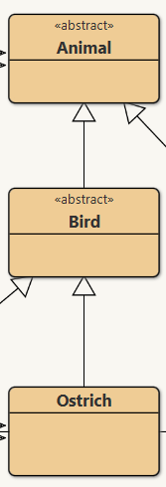







(The “abstract” keyword just means that the class is not allowed to be instantiated as an object. This is because, as the programmer, I decided that I don’t want any “Bird” objects to ever exist. This just helps me not create unwanted objects by mistake).

We can use an animal reference type to point to our Ostrich object because an Ostrich effectively is-an Animal.

Animal animal = new Ostrich(“Jerry”);

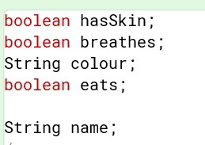The Ostrich object has all of the properties of Animal:

(these are general properties – all animals have them)

And the Ostrich object has all of the properties of Bird:

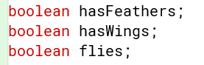

(these are general properties – all birds have them)

And the Ostrich object has the properties of Ostrich:

So all of these properties are available in the Ostrich object.

The Animal class has an abstract function.

An abstract method is a definition for a method that must be implemented by one its subclasses.



It’s purpose is to define the method signature so that any of the the subclasses can override it to make move do their own thing.

Next page..

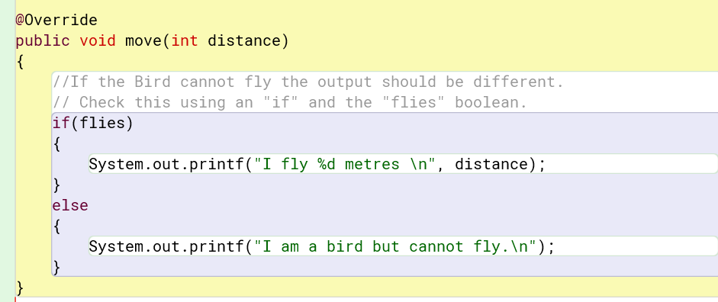The Bird class has a concrete method for move.

WHAT HAPPENS WHEN MOVE IS CALLED ON AN OSTRICH OBJECT.

Animal animal = new Ostrich(“Jerry”);

animal.move(5);

The program looks in the Ostrich class for the move method. It cannot find it. The program looks in the Ostrich’s parent class. It found a move(int distance) method in the Bird class. Cool. It runs that. A simple check is done to see if the Boolean “flies” is true, denoting that the animal can fly. As the ostrich cannot fly, its “flies” variable is false. So it “I am a bird but cannot fly” is printed out.